CHANGES HISTORY
PIC | Date | Remarks
BJM.MR | 2018.05.07 | Created
Ghaida | 2018.05.07

TOC
- Afa Nav
- Afa Benchmark
- Afa Return
- Master Portfolio Benchmark
- Parameter Securities Benchmark Class
- Parameter Securities Benchmark Class Composition
- Parameter Securities Benchmark
- Afa Securities Balance
- Afa Benchmark Balance

Diagram ENTITY RELATIONSHIP

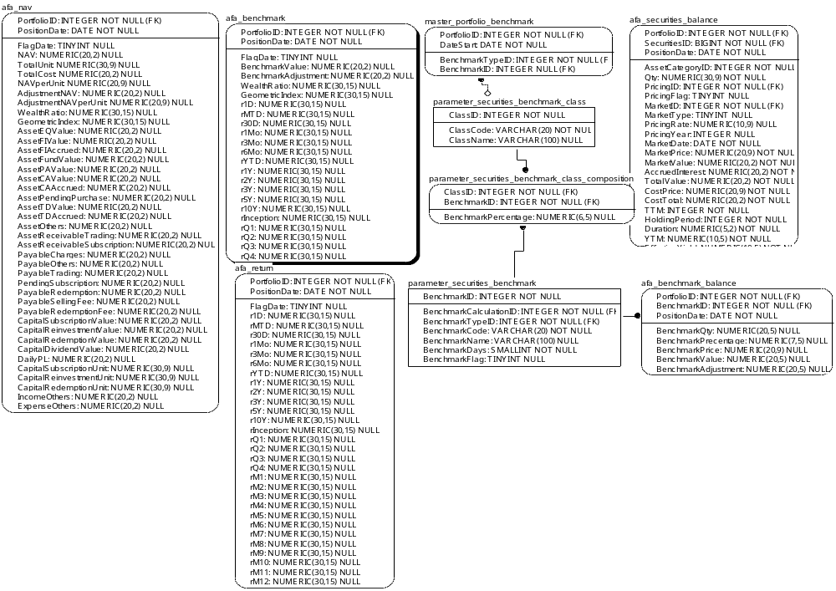

TABLE RELATIONSHIP
No | Table 1 | Table 2 | Type (1:1; 1:N; M:N) | Description
 | parameter_securities_benchmark_class | master_portfolio_benchmark | M:N
 | parameter_securities_benchmark_class | parameter_securities_benchmark_class_composition | M:N
 | parameter_securities_benchmark | parameter_securities_benchmark_class_composition | M:N
 | parameter_securities_benchmark | afa_benchmark_balance | M:N

Name |  | afa_nav
Objective
No | Column |  | Type | Rule  (PK, FK, Key, NN, Unik, Index) | Description
1. | PortfolioID |  | Integer | FK
2. | PositionDate |  | Date | NN
3. | Flagdate |  | TINYInteger | Null
4. | NAV |  | Numeric(20,2) | Null
5. | TotalUnit |  | Numeric(30,9) | Null
6. | TotalCost |  | Numeric(20,2) | Null
7. | NAVperUnit |  | Numeric(20,9) | Null
8. | AdjustmentNAVperUnit |  | Numeric(20,9) | Null
9. | WealthRatio |  | Numeric(30,15) | Null
10. | GeometricIndex |  | Numeric(30,15) | Null
11. | AssetEQValue |  | Numeric(20,2) | Null
12. | AssetFIValue |  | Numeric(20,2) | Null
13. | AssetFIAccrued |  | Numeric(20,2) | Null
14. | AssetFundValue |  | Numeric(20,2) | Null
15. | AssetCAValue |  | Numeric(20,2) | Null
16. | AssetCAAccrued |  | Numeric(20,2) | Null
17. | AssetPendingPurchase |  | Numeric(20,2) | Null
18. | AssetTDValue |  | Numeric(20,2) | Null
19. | AssetTDAccrued |  | Numeric(20,2) | Null
20. | AssetOthers |  | Numeric(20,2) | Null
21. | AssetReceivableTrading |  | Numeric(20,2) | Null
22. | AssetReceivableSubscription |  | Numeric(20,2) | Null
23. | PayableOthers |  | Numeric(20,2) | Null
24. | PayableTranding |  | Numeric(20,2) | Null
25. | PendingSubscripiton |  | Numeric(20,2) | Null
26. | PayableRedemption |  | Numeric(20,2) | Null
27. | PayableSellingFee |  | Numeric(20,2) | Null
28. | PayableRedemptionFee |  | Numeric(20,2) | Null
29. | CapitalSubsriptionValue |  | Numeric(20,2) | Null
30. | CapitalReinvestmentValue |  | Numeric(20,2) | Null
31. | CapitalRedemptionValue |  | Numeric(20,2) | Null
32. | CapitalDividendValue |  | Numeric(20,2) | Null
33. | DailyPL |  | Numeric(20,2) | Null
34. | CapitalSubscriptionUnit |  | Numeric(30,9) | Null
35. | CapitalReinvestmentUnit |  | Numeric(30,9) | Null
36. | CapitalRedemptionUnit |  | Numeric(30,9) | Null
37. | IncomeOthers |  | Numeric(20,2) | Null
38. | ExpenseOthers |  | Numeric(20,2) | Null
39. | AssetPAValue |  | Numeric(20,2) | Null

SAMPLE DATA
No | Column | Sample 1 | Sample 2 | Sample 3 | Sample 4
1. | PortfolioID | 48 | 48 | 48 | 48
2. | PositionDate | 12/31/2016 | 1/3/2017 | 1/4/2017 | 1/5/2017
3. | Flagdate | 3 | 0 | 0 | 0
4. | NAV | 139116279997.70 | 139012105672.64 | 139462940449.06 | 140255480508.50
5. | TotalUnit | 117505078.76 | 117505078.76 | 117461881.90 | 117462479.82
6. | TotalCost | 0.00 | 0.00 | 0.00 | 0.00
7. | NAVperUnit | 1183.92 | 1183.03 | 1187.3 | 1194.04
8. | AdjustmentNAVperUnit | 0.00 | 0.00 | 51103181.29 | -709910.42
9. | WealthRatio | 0.00 | 0.00 | 0.00 | 0.00
10. | GeometricIndex | 0.00 | 0.99924826 | 1.003609376 | 1.005676746
11. | AssetEQValue | 1 | 0.99924826 | 1.002854923 | 1.008547875
12. | AssetFIValue | 0.00 | 0.00 | 0.00 | 0.00
13. | AssetFIAccrued | 0.00 | 0.00 | 0.00 | 0.00
14. | AssetFundValue | 0.00 | 0.00 | 0.00 | 0.00
15. | AssetCAValue | 0.00 | 0.00 | 0.00 | 0.00
16. | AssetCAAccrued | 0.00 | 0.00 | 0.00 | 0.00
17. | AssetPendingPurchase | 0.00 | 0.00 | 0.00 | 0.00
18. | AssetTDValue | 0.00 | 0.00 | 0.00 | 0.00
19. | AssetTDAccrued | 0.00 | 0.00 | 0.00 | 0.00
20. | AssetOthers | 0.00 | 0.00 | 0.00 | 0.00
21. | AssetReceivableTrading | 0.00 | 0.00 | 0.00 | 0.00
22. | AssetReceivableSubscription | 0.00 | 0.00 | 0.00 | 0.00
23. | PayableOthers | 0.00 | 0.00 | 0.00 | 0.00
24. | PayableTranding | 0.00 | 0.00 | 0.00 | 0.00
25. | PendingSubscripiton | 0.00 | 0.00 | 0.00 | 0.00
26. | PayableRedemption | 0.00 | 0.00 | 0.00 | 0.00
27. | PayableSellingFee | 0.00 | 0.00 | 0.00 | 0.00
28. | PayableRedemptionFee | 0.00 | 0.00 | 0.00 | 0.00
29. | CapitalSubsriptionValue | 0.00 | 0.00 | 0.00 | 0.00
30. | CapitalReinvestmentValue | 0.00 | 0.00 | 0.00 | 0.00
31. | CapitalRedemptionValue | 0.00 | 0.00 | 0.00 | 0.00
32. | CapitalDividendValue | 0.00 | 0.00 | 0.00 | 0.00
33. | DailyPL | 0.00 | 0.00 | 0.00 | 0.00
34. | CapitalSubscriptionUnit | 0.00 | 0.00 | 0.00 | 0.00
35. | CapitalReinvestmentUnit | 0.00 | 0.00 | 0.00 | 0.00
36. | CapitalRedemptionUnit | 0.00 | 0.00 | 0.00 | 0.00
37. | IncomeOthers | 0.00 | 0.00 | 0.00 | 0.00
38. | ExpenseOthers | 0.00 | 0.00 | 0.00 | 0.00
39. | AssetPAValue | 0.00 | 0.00 | 0.00 | 0.00

Name |  | afa_benchmark
Objective
No | Column |  | Type | Rule  (PK, FK, Key, NN, Unik, Index) | Description
1. | PortfolioID |  | Integer | FK
2. | PostionDate |  | Date | NN
3. | FlagDate |  | TINYInteger | Null
4. | BenchmarkValue |  | Numeric(20,2) | Null
5. | BenchmarkAdjusment |  | Numeric(20,2) | Null
6. | Wealthratio |  | Numeric(30,15) | Null
7. | GeometricIndex |  | Numeric(30,15) | Null
8. | r1D |  | Numeric(30,15) | Null
9. | rMTD |  | Numeric(30,15) | Null
10. | r30D |  | Numeric(30,15) | Null
11. | r1Mo |  | Numeric(30,15) | Null
12. | r3Mo |  | Numeric(30,15) | Null
13. | r6Mo |  | Numeric(30,15) | Null
14. | rYTD |  | Numeric(30,15) | Null
15. | r1Y |  | Numeric(30,15) | Null
16. | r2Y |  | Numeric(30,15) | Null
17. | r3Y |  | Numeric(30,15) | Null
18. | r5Y |  | Numeric(30,15) | Null
19. | r10Y |  | Numeric(30,15) | Null
20. | rInception |  | Numeric(30,15) | Null
21. | rQ1 |  | Numeric(30,15) | Null
22. | rQ2 |  | Numeric(30,15) | Null
23. | rQ3 |  | Numeric(30,15) | Null
24. | rQ4 |  | Numeric(30,15) | Null
25. | rM1 |  | Numeric(30,15) | Null
26. | rM2 |  | Numeric(30,15) | Null
27. | rM3 |  | Numeric(30,15) | Null
28. | rM4 |  | Numeric(30,15) | Null
29. | rM5 |  | Numeric(30,15) | Null
30. | rM6 |  | Numeric(30,15) | Null
31. | rM7 |  | Numeric(30,15) | Null
32. | rM8 |  | Numeric(30,15) | Null
33. | rM9 |  | Numeric(30,15) | Null
34. | rM10 |  | Numeric(30,15) | Null
35. | rM11 |  | Numeric(30,15) | Null
36. | rM12 |  | Numeric(30,15) | Null

SAMPLE DATA
No | Column | Sample 1 | Sample 2 | Sample 3 | Sample 4
1. | PortfolioID
2. | PostionDate
3. | FlagDate
4. | BenchmarkValue
5. | BenchmarkAdjusment
6. | Wealthratio
7. | GeometricIndex
8. | r1D
9. | rMTD
10. | r30D
11. | r1Mo
12. | r3Mo
13. | r6Mo
14. | rYTD
15. | r1Y
16. | r2Y
17. | r3Y
18. | r5Y
19. | r10Y
20. | rInception
21. | rQ1
22. | rQ2
23. | rQ3
24. | rQ4
25. | rM1
26. | rM2
27. | rM3
28. | rM4
29. | rM5
30. | rM6
31. | rM7
32. | rM8
33. | rM9
34. | rM10
35. | rM11
36. | rM12

Name |  | afa_return
Objective
No | Column |  | Type | Rule  (PK, FK, Key, NN, Unik, Index) | Description
1. | PortfolioID |  | Date | NN
2. | PostionDate |  | TINYInteger | Null
3. | FlagDate |  | Date | NN
4. | r1D |  | Numeric(30,15) | Null
5. | rMTD |  | Numeric(30,15) | Null
6. | r30D |  | Numeric(30,15) | Null
7. | r1Mo |  | Numeric(30,15) | Null
8. | r3Mo |  | Numeric(30,15) | Null
9. | r6Mo |  | Numeric(30,15) | Null
10. | rYTD |  | Numeric(30,15) | Null
11. | r1Y |  | Numeric(30,15) | Null
12. | r2Y |  | Numeric(30,15) | Null
13. | r3Y |  | Numeric(30,15) | Null
14. | r5Y |  | Numeric(30,15) | Null
15. | r10Y |  | Numeric(30,15) | Null
16. | rInception |  | Numeric(30,15) | Null
17. | rQ1 |  | Numeric(30,15) | Null
18. | rQ2 |  | Numeric(30,15) | Null
19. | rQ3 |  | Numeric(30,15) | Null
20. | rQ4 |  | Numeric(30,15) | Null
21. | rM1 |  | Numeric(30,15) | Null
22. | rM2 |  | Numeric(30,15) | Null
23. | rM3 |  | Numeric(30,15) | Null
24. | rM4 |  | Numeric(30,15) | Null
25. | rM5 |  | Numeric(30,15) | Null
26. | rM6 |  | Numeric(30,15) | Null
27. | rM7 |  | Numeric(30,15) | Null
28. | rM8 |  | Numeric(30,15) | Null
29. | rM9 |  | Numeric(30,15) | Null
30. | rM10 |  | Numeric(30,15) | Null
31. | rM11 |  | Numeric(30,15) | Null
32. | rM12 |  | Numeric(30,15) | Null

SAMPLE DATA
No | Column | Sample 1 | Sample 2 | Sample 3 | Sample 4
1. | PortfolioID
2. | PostionDate
3. | FlagDate
4. | r1D
5. | rMTD
6. | r30D
7. | r1Mo
8. | r3Mo
9. | r6Mo
10. | rYTD
11. | r1Y
12. | r2Y
13. | r3Y
14. | r5Y
15. | r10Y
16. | rInception
17. | rQ1
18. | rQ2
19. | rQ3
20. | rQ4
21. | rM1
22. | rM2
23. | rM3
24. | rM4
25. | rM5
26. | rM6
27. | rM7
28. | rM8
29. | rM9
30. | rM10
31. | rM11
32. | rM12

Name |  | master_portfolio_benchmark
Objective
No | Column |  | Type | Rule  (PK, FK, Key, NN, Unik, Index) | Description
1. | PortfolioID |  | Integer | FK
2. | DateStart |  | Date | NN
3. | BenchmarkTypeID |  | Integer | FK
4. | BenchmarkID |  | Integer | FK, Null

SAMPLE DATA
No | Column | Sample 1 | Sample 2 | Sample 3 | Sample 4
1. | PortfolioID | 50 | 51 | 52 | 53
2. | DateStart | 2013-05-15 | 2013-05-15 | 2013-10-23 | 2013-10-23
3. | BenchmarkTypeID | 1 | 1 | 1 | 1
4. | BenchmarkID | 4 | 2 | 5 | 6

Name |  | parameter_securities_benchmark_class
Objective
No | Column |  | Type | Rule  (PK, FK, Key, NN, Unik, Index) | Description
1. | ClassID |  | Integer | NN
2. | ClassCode |  | Varchar(20) | NN
3. | ClassDescription |  | Varchar(100) | Null

SAMPLE DATA
No | Column | Sample 1 | Sample 2 | Sample 3 | Sample 4
1. | ClassID | 1 | 2 | 3 | 4
2. | ClassCode | LQ45 | JCI | ATD | 50JCI+50ATD1
3. | ClassDescription | Jakarta LQ45 Index | Jakarta Composite Index | Averate Time Deposit | 50% Jakarta Composite Index + 50% Average Time Deposit 1 Month

Name |  | parameter_securities_benchmark_class_composition
Objective
No | Column |  | Type | Rule  (PK, FK, Key, NN, Unik, Index) | Description
1. | ClassID |  | Integer | FK
2. | BenchmarkID |  | Integer | FK
3. | BenchmarkPercentage |  | Numeric(6,5) | Null

SAMPLE DATA
No | Column | Sample 1 | Sample 2 | Sample 3 | Sample 4
1. | ClassID | 1 | 2 | 4 | 4
2. | BenchmarkID | 2 | 1 | 1 | 4
3. | BenchmarkPercentage | 1 | 4 | 0.5 | 0.5

Name |  | afa_securities_balance
Objective
No | Column |  | Type | Rule  (PK, FK, Key, NN, Unik, Index) | Description
1. | PortfolioID |  | Integer | FK
2. | SecuritiesID |  | BIGInteger | FK
3. | PositionDate |  | Date | NN
4. | AssetCategoryID |  | Integer | FK
5. | Qty |  | Numeric(30,9) | NN
6. | PricingID |  | Integer | FK
7. | PricingFlag |  | TINYInteger | Null
8. | MarketID |  | Integer | FK
9. | MarketType |  | TINYInteger | Null
10. | PricingYear |  | Integer | Null
11. | PricingRate |  | Numeric(10,9) | Null
12. | MarketDate |  | Date | Null
13. | MarketPrice |  | Numeric(20,9) | NN
14. | MarketValue |  | Numeric(20,2) | NN
15. | AccruedInterest |  | Numeric(20,2) | NN
16. | TotalValue |  | Numeric(20,2) | NN
17. | CostPrice |  | Numeric(20,2) | NN
18. | CostTotal |  | Numeric(20,2) | NN
19. | TTM |  | Integer | NN
20. | HoldingPeriod |  | Integer | NN
21. | Duration |  | Numeric(5,2) | NN
22. | YTM |  | Numeric(10,5) | NN
23. | EffectiveYield |  | Numeric(10,5) | NN

SAMPLE DATA
No | Column | Sample 1 | Sample 2 | Sample 3 | Sample 4
1. | PortfolioID | 74 | 74
2. | SecuritiesID | 1 | 245
3. | PositionDate | 2017-08-18 | 2017-08-18
4. | AssetCategoryID | 1 | 1
5. | Qty | 100000.000000000 | 120000.000000000
6. | PricingID | 1 | 1
7. | PricingFlag | 0 | 0
8. | MarketID | 1 | 1
9. | MarketType | 1 | 1
10. | PricingYear | 0 | 0
11. | PricingRate | 0 | 0
12. | MarketDate | 2017-08-18 | 2017-08-18
13. | MarketPrice | 16500.000000000 | 10000.000000000
14. | MarketValue | 1650000000.00 | 1200000000.00
15. | AccruedInterest | 0.00 | 0.00
16. | TotalValue | 1650000000.00 | 1200000000.00
17. | CostPrice | 16500.000000000 | 10000.000000000
18. | CostTotal | 1650000000.00 | 120000000000.00
19. | TTM | 0 | 0
20. | HoldingPeriod | 0 | 0
21. | Duration | 0 | 0
22. | YTM | 0 | 0
23. | EffectiveYield |  | 0

Name |  | afa_benchmark_balance
Objective
No | Column |  | Type | Rule  (PK, FK, Key, NN, Unik, Index) | Description
1. | PortfolioID |  | BIGInteger | NN
2. | BenchmarkID |  | Integer | FK
3. | PositionDate |  | Integer | FK, Null
4. | BenchmarkQty |  | BIGInteger | FK
5. | BenchmarkPercentage |  | Date | NN
6. | BenchmarkPrice |  | Varchar(255) | NN
7. | BenchmarkValue |  | Numeric(20,2) | Null
8. | BenchmarkAdjustment |  | Numeric(20,2) | Null

SAMPLE DATA
No | Column | Sample 1 | Sample 2 | Sample 3 | Sample 4
1. | PortfolioID
2. | BenchmarkID
3. | PositionDate
4. | BenchmarkQty
5. | BenchmarkPercentage
6. | BenchmarkPrice
7. | BenchmarkValue
8. | BenchmarkAdjustment

